**Enrichment of microbial communities for the conversion of lignocellulose into monocarboxylates**

Christina Schäfer1, Maria L. Bonatelli1, Sabine Kleinsteuber1, Hauke Harms2, Heike Sträuber1

1 Helmholtz Centre for Environmental Research, Department of Microbial Biotechnology, Leipzig, Germany

2 Helmholtz Centre for Environmental Research, Department of Applied Microbial Ecology, Leipzig, Germany

**Abstract**

The production of bio-chemicals by anaerobic fermentation of lignocellulose with microbial consortia is environmentally friendly, because lignocellulose is an abundant and renewable resource, but lignocellulose is highly resistant to enzymatic hydrolysis. The aim of this study was to enrich microbial communities on cellulose and hemicellulose, to obtain functional communities of fermenting bacteria capable of consuming lignocellulose and producing valuable platform chemicals. Inocula of various origins (cow manure, compost and digestate, and marshland soil) were anaerobically batch-cultivated with cellulose or xylan to enrich bacterial cultures capable of hydrolyzing and fermenting these compounds. The growth of microbial biomass (protein), pH development and product formation (HPLC and GC) were monitored, and 16S rRNA gene amplicon sequencing and metagenome analysis was used to access microbial composition and function. In the most efficient enrichment cultures substrate consumption have been measured. All cellulose enrichment cultures produced acetic acid. In most cellulose-enrichment cultures, the genera *Fibro-01* and *Bacteroides* were identified as the dominant genera, with the former being associated with microcrystalline cellulose. When enriched in xylan, cultures from cow manure produced lactic acid and from compost and digestate caproic acid. Most of the abundant MAGs found in the xylan-degrading communities were from the Clostridia class, including *Clostridium*, *Lacrimispora*, and *Robinsoniella*. Analysis of the metabolic potential revealed the presence of genes encoding cellulose and hemicellulose hydrolases (e.g., endoglucanase and xylanase), along with genes for lactate dehydrogenase, which catalyzes the conversion of pyruvate to lactate. Enrichment cultures growing on cellulose produced mainly CO2, whereas cultures with xylan contained, in addition substantial, amounts of H2. The degradation of the crystalline cellulose led in several cases to higher product amounts than with the amorphous cellulose. Bacteria have been enriched, who are able to degrade cellulose or hemicellulose and produce volatile fatty acids, or even caproic acid. The most efficient enrichment cultures could be used in prospective synthetic consortia or for bioaugmentation.

**Keywords:** anaerobic fermentation, chain elongation, cellulose, xylan, metagenome assembled genome, caproate, lactate

**1. Introduction**

Industries have to change and we need to establish a bio-based circular economy where waste is used as a resource for renewable energy and chemicals. It will be necessary to integrate various types of conversion processes, in order to manage the complexity of biowaste (Venkata Mohan et al. 2016; Phan-huy et al. 2023b). Straw is such a complex biowaste, which made up 75 % of the agricultural residues in 2019 (Scarlat et al. 2019). In 2021 around 42-63 Mt/year of straw was available in the European Union (EU), taking into account technical harvest, feasibility, sustainable removal rate and existing uses (Phan-huy et al. 2023a). The common practice of burning non-used straw, although prohibited, leads to greenhouse gas (GHG) emissions (Ortiz et al. 2008; Guobao Song et al.; Pereira et al. 2019). Therefore, the EU supports the usage of straw as a feedstock for the bioeconomy (DG for Research and Innovation of the EC 2018). Nevertheless, the possibilities for treating such large quantities of waste straw have so far been limited, due to its complex chemical structure (Zheng et al. 2009). It contains 35-45% cellulose, 20-30% hemicellulose and 8-15% lignin (Saha and Cotta 2006). Especially the interweaving of cellulose with the other polysaccharides leads to a high resistance to enzymatic hydrolysis.

Microbial communities have the potential to efficiently hydrolyse complex polysaccharides such as cellulose and hemicellulose and to produce high titres of biochemicals such as short-chain carboxylic acids (SCCAs) or even medium-chain carboxylic acids (MCCAs) under anaerobic conditions in a suitable growth medium. Microbial communities are able to efficiently execute complex functions that exceed the capabilities of pure cultures due to their functional diversity and division of labour. Additionally, they have a high resistance and resilience to environmental changes (Kato et al. 2008). For establishing microbial communities with specific properties, the enrichment culture technique is a widely recognised and highly effective tool (Cheng et al. 2009; Lu et al. 2005). With the intention to enrich cellulolytic microorganism, the inocula selection is crucial. Microorganisms capable of cellulose and hemicellulose degradation can be found in various habitats, e.g. soil, compost, decaying plant material, sewage sludge, forest waste, and rumen (Amore et al. 2013).

In order to digest plant material effectively ruminants like cows maintain a symbiotic relationship with a diverse community in their rumen, consisting of archaea, protozoa and fungi. They release or expose hydrolytic exoenzymes to degrade plant polymers like cellulose, hemicellulose, and lignin components. The hydrolysates are then used for the production of short chain fatty acids, serving as nutrients for consumption (Henderson et al. 2015; Denman and McSweeney 2006; Zened et al. 2013). Hence, cow manure is a promising source to find lignocellulose degrading bacteria, Anveshitha et al. (2023) and Das et al. (2010) successfully obtained cellulose degrading microbial isolates from cow dung.

Another potential resource is compost, since it contains an immense diversity of microbes for the efficient degradation of lignocellulosic biomass (Hassen et al. 2001; Martinez et al. 2004; Allgaier et al. 2010). Mayende et al. (2006) were able to isolate a bunch of thermophilic cellulose degrading bacteria from compost. Zhou Hong-li et al. (2015) collected in a study from a mixture of fresh cow dung and fermentation biogas slurry potential cellulase producers. Digestates found in anaerobic engineering projects have been used as inocula in several research studies (Elbeshbishy et al. 2012). Li et al. (2010) tested the influence of four inocula from different digestates on the methane production with pre-treated corn stover as a substrate.

The biomass of marshland contains mainly polymers such as lignocellulose and hemicellulose/cellulose (Trckova et al. 2005). Additionally, marshland soils are mostly anoxic systems with a low concentration of electron acceptors (Paul 2003), Westermann, Moore, 1990).   
The anoxic zone begins already at a depth of 15-30 cm (Timo Mallmann 2008). Whereby the majority of the organic matter is degraded via anaerobic processes like fermentation and methanogenesis (Zinder 1993; Schink 1997). These circumstances make marshland soil a potential source for anaerobic lignocellulose degrading bacteria.

The main aim of this study was to enrich anaerobic microbial communities that can degrade lignocellulose and produce carboxylates and alcohols that could be used as precursors for the production of MCCAs by microbial chain elongation. Cow manure, marshland soil and a mixture of compost and digestate were used as inocula. The enrichments were batch-cultured in successive transfers with amorphous (PASC: phosphoric acid swollen cellulose) or crystalline (Avicel®) cellulose or with xylanm which was sued as a model for hemicellulose. The enrichment of specific bacterial taxa was monitored by molecular analysis of the community composition in the individual transfers. In addition, the functional potentials of the enrichment cultures were revealed by metagenome analyses.

**2. Materials and methods**

**2.1 Biological material**

Four inocula sources were used in this work. Marshland soil was collected from the natural reserve Presseler Heide (51°34’35.6” N; 12°45’29.8” E) in December 2021. Cow manure sample (Volatile Organic Acids (VOA): 8.22 g/L, pH: 7.18) has its origin in a cesspit from Uwe & Olaf Kupfer Agricultural Enterprise within the Leipzig region and was taken in November 2021. Samples were collected with a sediment thrill in a depth of at least 30 cm, and presented a pH of 4.2. Compost samples were taken from a compost heap, which was fed mainly with plant material from a private garden in Leipzig in December 2021. The sample had a pH of 7.59. Digestate samples were taken from a bioreactor (performance metrics during sample collection: pH: 7.51, VOA: 0.68, VOA/Total inorganic carbon: 0.13, NH4-N: 1.88, Dry matter content: 2.87%, Organic dry matter: 78.6, 39°C, dwell time: 38,6 days, volume load: 2.5).

Collection process consisted in storing the samples in bottles that were previously flushed with nitrogen. The bottles were completely filled, closed with airtight lids and stored at 4°C until the beginning of the experiment.

**2.2 Experimental design of the enrichment culture process**

A minimal medium was designed for the enrichment (see Suppl. Table 1). In order to get rid of oxygen, medium was stirred for 30 min in an anaerobic chamber (98% N2 and 2% H2). Then it was purged with nitrogen for 10 min at 1000 ln/min to get rid of hydrogen and autoclaved (20 min, 121°C, 1 bar). The medium was autoclaved only once until transfer number 10 to avoid breakage of the C-sources through the heat. The pH was adjusted to 5.5 ±0.5 for the enrichment cultures with marshland soil as inoculum and to 7.2±0.5 for the other enrichment cultures. The pH was measured and adjusted, if necessary in the first week every 2-3 days. From the first transfer on it was done twice to three times a week until transfer-number 5 or 4/3 (enrichment cultures with PASC) and after that once a week. In case methane production was observed during the enrichment process, BES (2-bromoethanesulfonate was added to the medium (12 g/L (S. H. Zinder et al.)) in the following two transfers.

Three different carbon sources were used, being xylan (hemicellulose), PASC (amorphous cellulose) and Avicel® (microcrystalline cellulose). To the preparation of PASC, refer to the supplementary material. The concentration of the respective C-source was 5 g/L.

Initially, anaerobic serum bottles containing the medium and the C-sources were inoculated with 1 g of inoculum in an anaerobic chamber. For compost and digestate 0.5 g of each inoculum were added together. The cultures were then incubated at 33°C for 7 to 15 days. Then, 5 ml of each enrichment culture was transferred to a new anaerobic serum bottle with fresh medium and C-source. The controls were inoculated, but did not contain a C-source.

For the enrichment cultures from cow manure and marshland soil with PASC and Avicel®, from transfer number 10, we observed a low production of VFAs, so in parallel with the running experiment with SynCon1, we re-started the experiment with SynCon2. The SynCon2 media does not contain ascorbic acid, since it could be used as an alternative C-source. Furthermore, the new media contains two additional trace elements in order to exclude them as potential limiting factors for the growth of the microorganisms. The SynCon2 media was autoclaved twice from transfer number 6. In the end, only the enrichment culture with inoculum source from cow manure with Avicel® as substrate presented increments in VFAs production, all the other enrichments were carried with SynCon1.

**2.3 Analysis methods**

**2.3.1 Organic acid measurement**

Samples for HPLC analysis were centrifuged at 6000 g for 10 min at 4°C. The supernatant was collected and filtered (0.22 µm, cellulose acetate). The analysis was performed in a Shimadzu (USA) chromatograph with a precolumn PL Hi-Plex H Guard (50 mm length, 7.7 mm diameter (Agilent technologies) and Hi-Plex H column (300 mm length, 7.7 mm diameter (Agilent Technologies)). The conditions of the run were: oven temperature 55°C, injection volume of 20 µl, 5 mM sulfuric acid as eluent, flow rate of 0.7 ml min-1. More specifications about the instrumental settings can be found at Supplementary Table 2. A reflexion index detector and the software CLASS-VP (Shimadzu, Japan) detected glucose, ethanol, lactic acid, formic acid, acetic acid, propionic acid, iso-butyric acid, n-butyric-acid, iso-valeric acid, 1-propanol, n-valeric acid, 1-butanol, iso-caproic-acid, caproic-acid, 1-pentanol, heptanoic-acid and octanoic-acid.

For the analysis of the liquid products of the enrichment cultures with marshland soil VFA gas chromatography was used, since the MES-buffer has the same retention time during the HPLC analysis as propionic acid. Therefore 3 ml of sample, 1 ml of control standard (2-methyl butyric acid, 184 mg/l), 0.5 ml methanol and 2.5 ml sulphuric acid (diluted 1:5) were mixed together in a 20-ml headspace vial and tightly closed with an aluminium crimp cap with PTFE/silicone septum. Till the measurement the samples are stored in the refrigerator at 4 °C. Analysis was performed on a 7890 A gas chromatograph with a flame ionization detector (FID) from Agilent technologies. The head-space sampling was done by an autosampler (Turbomatrix110; Perkin Elmer.). For more specifications about the instrumental settings of the headspace-sampler, refer to Supplementary Table 3. The injection mode was split 1:10. The injector temperature was kept at 220 °C. For the separation a DB-FFAP column (60 m x 0.25 mm x 0.5 µm; Agilent Technologies) was used. The gas chromatography system was operating at programmed-temperature-mode as follows: initial temperature 40 °C hold for 20 min, linear ramp 10 °C/min till 200 °C and hold for 10 min. The FID heated at 260 °C was used for data acquisition. A deactivated transfer line with inner diameter of 0,25 mm was used for the connection between the GC and the headspace autosampler.

**2.3.3 Protein measurement**

For total protein measurement, 2-1 ml of sample was centrifuged at 6000 g for 10 min at 4°C. To the pellet, 500 µl lysis-buffer (0.15 M NaOH and 0.45% NaCl) was added. Samples were incubated for 10 min at 95 °C, then they were centrifuged at 10 000 g for 10 min at 4 °C. Depending on the estimated protein concentration, 100 to 500 µl of the supernatant was mixed with a final volume of 1 ml of Bradford reagent (PanReac AppliChem ITIW Reagents). Negative control used only the lysis-buffer solution. This mixture was vortexed and incubated for 2 min at RT in the dark. The samples were then transfer to cuvettes (UV-cuvettes: semi-micro 1.6 ml) and measured at 595 nm with a photometer (Spectrophotometer Genesys 10S UV-VIS (Thermo Fisher Scientific Inc.)). The protein concentration was then calculated with a standard curve, which was constructed with bovine serum albumin (BSA) as reference.

**2.3.4 Micro-GC**

The gas composition of the cultures was analysed by taking a 3 ml sample of the serum bottles headspace with a syringe, which was flushed with nitrogen before. The syringe was closed with a rubber stopper immediately after leaving the headspace of the bottle. The measurement took place with the gas-phase chromatograph Micro GC CP-2002P (Chrompack, Netherlands). Module A (Molsieve 5A PLOT (30 m length, 0.53 mm diameter) with a Rt-Q-Bond precolumn (3 meters length) separated He, H2, N2, Ar/O2, CO and CH4 based on gas-solid separation. The Rt-Q-Bond column (12 meters length) was used as the main column for Module B. It separates CO2, Ethylene, H2S, and H2O. The detected gases H2, CO2, CH4 and N2 were normalized to 100%.

**2.3.5 Phenol-sulfuric acid method for measurement of cellulose and hemicellulose**

The most efficient enrichment cultures have been analysed regarding their capability of degrading xylan/ Avicel®. Therefore, the enrichment cultures, after finishing the enrichment process, have been cultivated for either two (xylan enrichment cultures) or five weeks (Avicel® enrichment cultures). The cultivation bottles were then opened, and samples were taken while stirring the culture to ensure a homogeneous sampling. The xylan or cellulose content have been then measured based on the modified phenol-sulphuric method as described by Updegraff (1969) and Hemme et al. (2011). Samples have been centrifuged at 5000 g for 15 min at 4°C. In case the cellulose content has been aimed to be measured, the supernatant has been discarded and the pellet was resuspended in Aqua dest. and heated at 95 °C for 30 min and washed afterwards twice with Aqua dest. at 5000 g and 4°C for 15 min. Since the xylan used in this study was soluble, the supernatant from the samples were used to measure the xylan content and heated as well, but the washing steps were not necessary. To the pellet or supernatant 1 ml of 65% sulfuric acid have been added and incubated for 1 h. Samples have been then diluted, if necessary. 200 µl of sample was then combined with 200 µl of 2% phenol and 1 ml of 98% sulfuric acid and incubated for 30 min at RT. Then the extinction has been detected at 490 nm. The standard curve has been established with xylan (10-150 mg/L) or Avicel® (5-1000 mg/L).

For each enrichment cultures two biological replicates have been analysed as well as one positive control without xylan or cellulose addition, which has been inoculated, too. Sterile controls were brought along, and their xylan or cellulose content was correlated with the measured values in the enrichment cultures. Sampling at the experiment's outset was impractical as the bottles had to be fully opened for a uniform sample collection. So, the cellulose or xylan content from the sterile control was used as the initial reference value.

**2.4 DNA sequencing analysis**

**2.4.1 DNA extraction and sequencing**

DNA from the enrichment culture samples were extracted using NucleoSpin® Tissue DNA kit (Macherey-Nagel, Düren, Germany), according to the manual with minor modifications. Shortly, samples were incubated for five hours in the pre-lysis sample step, followed by the recommended protocol, up until the DNA elution step, where we proceed with the recommendations of the manual to increase yield and concentration. DNA quantification was done by QUBIT with dsDNA BR Assay Kit (Invitrogen, Schwerte, Germany). When necessary, DNA was concentrated using Amicon® centrifugal filters (Merck, Darmstadt, Germany).

Amplicon sequencing data was generated using the set of primers 341f (5’-CCT ACG GGN GGC WGC AG-3’) and 785r (5’-GAC TAC HVG GGT ATC TAA TCC-3’), which target the V3-V4 regions of the 16S rRNA gene (Klindworth et al. 2013). Library was prepared with in the Illumina Nextera XT Index Kit (Illumina, San Diego, CA, USA) MiSeq platform (Illumina, San Diego, CA, USA), with the Nextera XT Index Kit (Illumina, San Diego, CA, USA). Then, we analysed the data on R software v.4.3.0 (R Core Team, 2023) using dada2 software v.1.28.0 (Callahan et al. 2016) to infer the amplicon sequence variants (ASVs), and phyloseq v.1.44.0 (Callahan et al. 2016; McMurdie and Holmes 2013) to perform the compositional analysis. The database used for taxonomy assignment was Silva v. 138.1 (Quast et al. 2013).

Shotgun metagenome analysis were performed with stable enrichment communities’ cultures, meaning, only the second to last and/or the last transfers of every enrichment culture were used. The sequencing was performed using Illumina NovaSeq system (2x150 bp) by Azenta Life Sciences, Leipzig, DE.

The software MuDoGeR v.1.0.1 (Rocha et al. 2024) was used recover the metagenome assembled genomes (MAGs) from the enrichment culture samples. To that, metaSpades v. 3.15.5 N (Nurk et al. 2017) was used to do the assembly, and metaWRAP v. 1.3.2 (Uritskiy et al. 2018) to perform the binning process. MAGs quality and taxonomy were assessed with CheckM v. 1.0.18 (Parks et al. 2015) and GTDB-tk v. 2.1.1 (Chaumeil et al. 2019), respectively. Annotation was performed with DRAM v. 1.4.6 (Shaffer et al. 2020) in the high-quality MAGs (completeness > 90% and contamination < 5%). The genes related with important functions for the enriched communities were manually curated in the MAGs (Suppl.Table 4).

Reads were mapped to the MAGs using Bowtie2 v. 2.5.1 (Langmead and Salzberg 2012) and CoverM v. XXX (Aroney et al. 2024) was used to calculate MAGs relative abundance. Proksee (Grant et al. 2023) was used to genome visualization and for the calculation of the average nucleotide identity (ANI) with the FastANI software (Jain et al. 2018).

Amplicon sequence data and MAGs generated in this manuscript were deposited on the National Center for Biotechnology Information (NCBI) database under the Project number XXX.

**2.4.2 Statistical analysis**

Alpha-diversity indexes Shannon and Simpson, and the Non-metric Multi-dimensional Scaling (NMDS) ordination considering the Bray-Curtis distance were calculated with phyloseq v.1.44.0 (Callahan et al. 2016; McMurdie and Holmes 2013). Permanova test was calculated using vegan v. 2.6.4 (Oksanen et al. 2022). Spearman’s correlation analysis was performed using the R stats package (R Core Team, 2023).

**Results**

**3.1 Bacterial composition and chemical compounds production are influenced by inoculum origin source and substrate**

The enrichment culture process reduced the bacterial diversity found in the inoculum sources, as expected (Suppl. Figure 1-A). This was noticeable throughout the process, where samples from the beginning of the enrichment process tended to show higher values of diversity (Figure 1-A). Origin source and substrate also influenced bacterial diversity, being that Avicel® overall presented higher diversity values, while the Marshland inoculum source showed the lowest bacterial diversity (Figure 1-A).

Interestingly, ordination of the samples showed clear clusterization considering origin inoculum source and substrate used, and this was confirmed both by low stress-value of the NMDS plot and PERMANOVA test (Figure 1-B). For cellulose substrates PASC and Avicel®, samples of different origin source did not clearly separate, but this was different when comparing cellulose substrates and xylan, where we see a horizontal separation (Figure 1-B). Moreover, when considering different origin sources, we can notice a vertical separation of samples, where Marshland samples are more distinct then cow manure and compost and digestate (Figure 1-B).

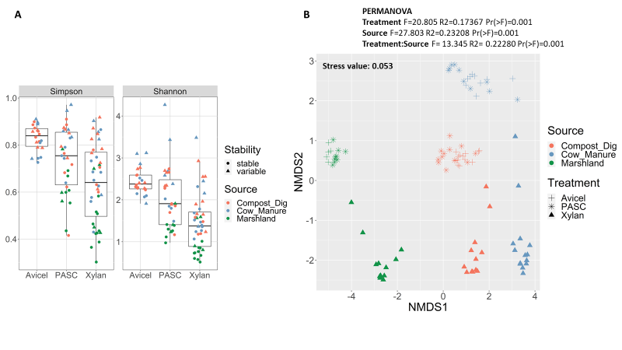

Figure 1. Alpha- and Beta-diversity analyses of the enrichment cultures from the inoculum sources compost and digestate, cow manure and marshland soil. (A) Simpson and Shannon indexes of the different inoculum sources together with the substrates Avicel®, PASC and xylan. (B) Non-metric Multi-dimensional Scaling (NMDS) ordination considering Bray-Curtis distance.

Overall, taxonomy analysis showed that since the beginning of the enrichment process, community composition presented changed from those seen in the origin inoculum sources, even considering high taxonomy levels as bacterial phylum (Suppl. Figure 1-B and 2). Throughout the enrichment process, we can highlight the presence of the phyla Firmicute, Fibrobacterota, Desulfobacterota and Bacteroida (Suppl. Figure 2). Differences between enrichment culture process with distinct origin inoculum sources and carbon substrate are described below.

**3.1.1 Compost and digestate**

Enrichment cultures with compost and digestate as origin inoculum and cellulose as substrate produced mainly acetic acid, propionic acid and ethanol (Figure 2-A). At the end of the enrichment process with cellulose, only acetic acid was detected in PASC, while in Avicel® acetic acid and propionic acid were detected. Product concentrations were higher in the enrichment with Avicel® (acetic acid: 1047 µg/ml and propionic acid: 538 µg/ml). Taxonomy results showed that *Fibrobacter* and *Bacteroides* genera are predominant in Avicel®, while for PASC *Enterococcus* was predominant until CD_P_11, but in the last transfer (CD_P_12) the composition changed to *Treponema*, *Lachnoclostridium* and *Desulfovibrio* as the most abundant (Figure 2-B).

When xylan was used as substrate, many other products productions were observed in the compost and digestate enrichment culture, such as butyric acid and isobutyric acid. Interestingly, caproic acid production was also observed (Figure 2-A). The genera *Lachnoclostridium*, *Desulfovibrio* and *Caproiciproducens* were consistently observed throughout the enrichment process (Figure 2-B).

The gas composition did not change in both cultures with PASC or Avicel® during the enrichment (Suppl. Figure OR Table). Before the first transfer, methane was observed but the addition of BES in the two following cultures were able to supress the methane production. The microorganisms produced mainly carbon dioxide with proportion between 3.2 and 11% (Suppl. Figure OR Table). Next to the carbon dioxide formation also hydrogen have been produced with xylan. The protein values, similar to the product concentrations, are higher in the beginning of the enrichment and lay at the end of the enrichment between 79 and 267 µg/ml (Figure 2-A).

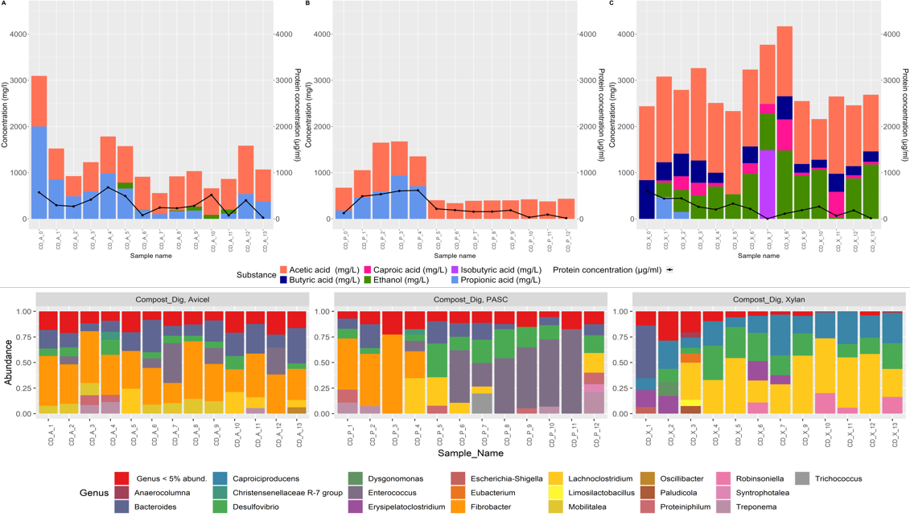

Figure 2. Enrichment culture with compost and digestate as inoculum source. Organic acid products and protein concentration (A-C), and bacterial taxonomy composition (D-E) are shown. Every bar represents a distinct enrichment transfer bottle.

**3.1.2 Cow manure**

The cellulose enrichment cultures with cow manure as inoculum are similar to the above described with compost and digestate. Mainly the production of acetic and propionic acid was observed at the end of the enrichment (Figure 3-A). However, they differ regarding the product concentration, where Avicel® in SynCon2 medium presented higher concentration (acetic acid: 1330 µg/ml and propionic acid: 618 µg/ml), when compared with PASC in SynCon1 medium (about 400 µg/ml acetic acid). It is worth mentioning that using SynCon1 medium with PASC did not improved product formation. Regarding bacterial composition, *Fibrobacter* and *Bacteroides* were the most abundant in Avicel® enrichment culture, while *Desulfovibrio*, *Bacteroides* and *Trichococcus* were more abundant in PASC (Figure 3-B).

Xylan enrichment culture from cow manure presented the production of lactic acid and acetic acid in high concentration throughout the whole process, being that in the last transfer the concentrations of lactic acid and acetic acid were 1245 and 2377 mg/L, respectively (Figure 3-A). And having xylan as substrate, *Robinsoniella*, *Lentilactobacillus* and *Lacticaseibacillus* were the most bacterial genera found.

During the enrichment the gas composition changed barely and the BES-addition in the beginning was enough to inhibit further methane production (Suppl. Figure OR Table). With xylan again hydrogen have been detected but in lower concentrations than in the cultures with compost and digestate (Suppl. Figure OR Table). The protein content resembled with cellulose or hemicellulose those from compost and digestate. The ones with xylan showed higher concentrations. At the end of the enrichment up to 359 µg/ml. (Figure 3-A).

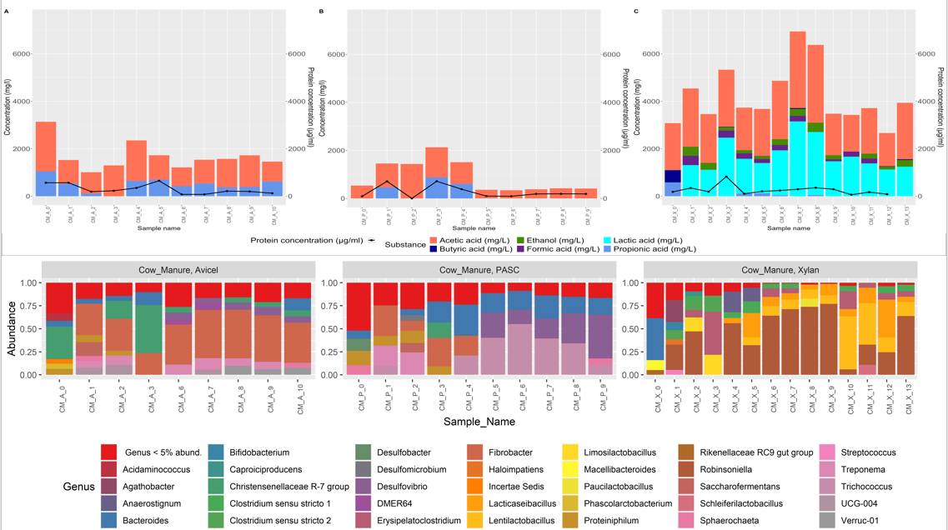

Figure 3. Enrichment culture with cow manure as inoculum source. Organic acid products and protein concentration (A-C), and bacterial taxonomy composition (D-F) are shown. Every bar represents a distinct enrichment transfer bottle. Cultivated in SynCon2-media with Avicel® and in SynCon1-media with PASC and xylan.

**3.1.3 Marshland soil**

The cellulose enrichment cultures with marshlands soil as inoculum showed low product formation (Figure 4-A). In both cultures only, acetic acid was detected. The concentrations were slightly higher with PASC than with Avicel®. The results for bacterial taxonomy shown are the ones where DNA was able to be recovered. Both substrates enriched similar bacterial genera, being *Desulfovibrio* and *Microbacter* were the most abundant. (Figure 4-B).

The enrichment culture with xylan and marshlands soil as inoculum performed more satisfactorily. Butyric acid and acetic acid were produced in higher concentration, being that the last transfer had 1483 and 419 mg/L of butyric acid and acetic acid, respectively (Figure 4-A). And bacterial composition was fairly stable throughout the process, being *Clostridium* the most abundant genera throughout the process (Figure 4-B).

The gas composition did not change much in the cultures with PASC or Avicel® during the enrichment and only carbon dioxide was produced, too (Suppl. Figure OR Table). The addition of BES was not done for these enrichment cultures, since no methane formation appeared. Furthermore, high hydrogen concentrations in the gas phase (up to 47%) were measured. Comparing all enrichment cultures with each other, marshland soil showed the lowest protein concentrations and reached only about 400 µg/ml in the enrichment culture with xylan (Figure 4-A).

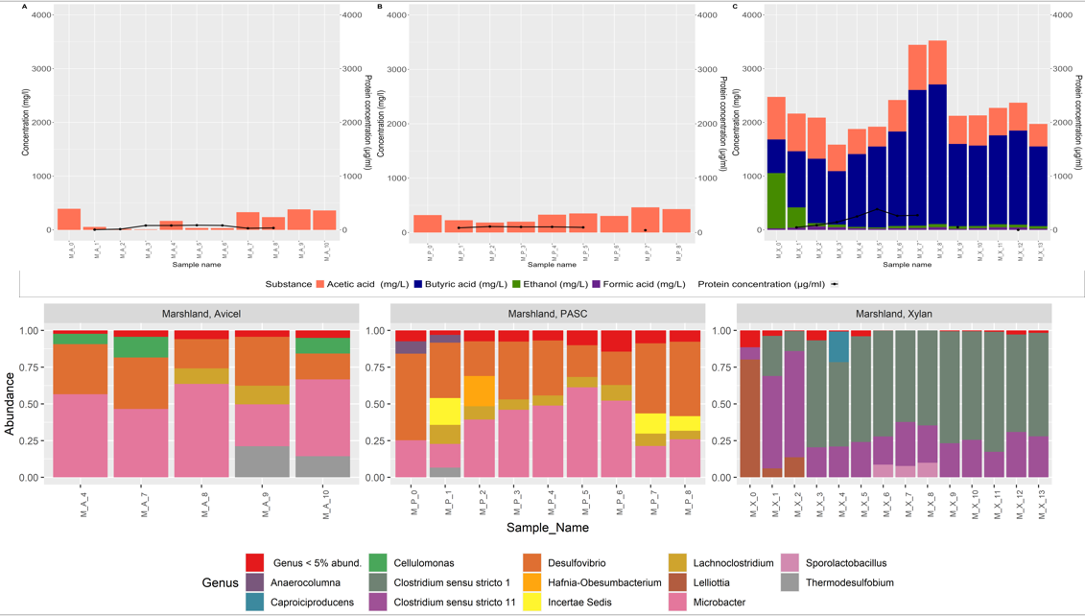

Figure 4. Enrichment culture with marshland soil as inoculum source. Organic acid products and protein concentration (A-C), and bacterial taxonomy composition (D-F) are shown. Every bar represents a distinct enrichment transfer bottle.

**3.2 Correlation analysis**

Correlation analysis with the top 20 ASVs showed some bacterial genera that might be related with organic acid and gas production. *Fibrobacter* (ASV1 and ASV12) was a genus strongly correlated with propionic acid, while lactic acid was correlated with Bifidobacteriaceae (ASV2), *Robinsoniella* (ASV6) and *Erysipelatoclostridium* (ASV17). *Clostridium* genus (ASV5 and ASV10) were positively correlated with many organic acids and CO2 and H2, while *Caproiciproducens* (ASV13) were strongly correlated with caproic acid (Figure 5).

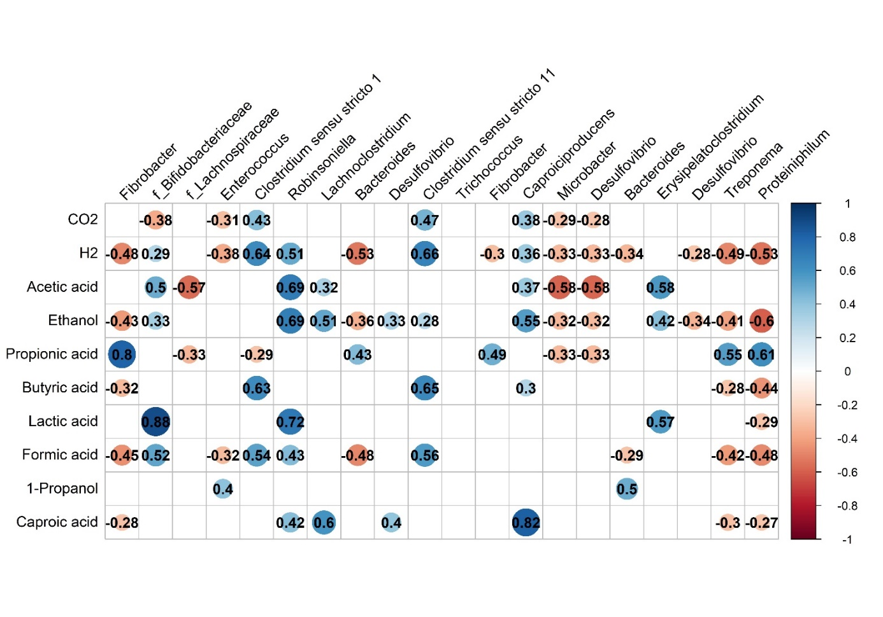

Figure 5 – Spearman’s correlation analysis with the top 20 Amplicon sequence variant (ASVs) of the enrichment cultures. Only showing values that were statistically significant (p<0.01).

**3.3 Enriched communities’ composition and potential**

We recovered 101 high-quality (completeness > 90% and contamination < 5%) metagenome-assembled genomes (MAGs) from the enrichment cultures (Suppl. Table 5). Around 80% or more of the reads used in the assembly successfully aligned against the MAGs (Suppl. Table 6), meaning we have successfully retrieved the main bacterial representatives in each enrichment culture.

Interestingly, bacterial diversity indexes and ordination of samples followed a similar pattern observed through the amplicon sequencing data (Suppl. Figure 1). Taxonomy of the MAGs reported many phyla present in high relative abundance in the amplicon sequencing data, such as Bacteroidota, Desulfobacterota and Firmicutes (Figure 5, Suppl. Figure 2).

When we look at the distribution of the different phyla in the enrichment cultures, we noticed that generally neither the inoculum origin source, nor the substrate seem to select for a particular taxon (Figure 6). This was also observed in more lower taxonomy levels (Suppl. Table 5). The exception was the enrichment cultures with xylan as substrate. Most isolates belong to the phylum Firmicutes (Firmicutes and Firmicutes_A), but one that belongs to Actinobacteriota (Figure 6).

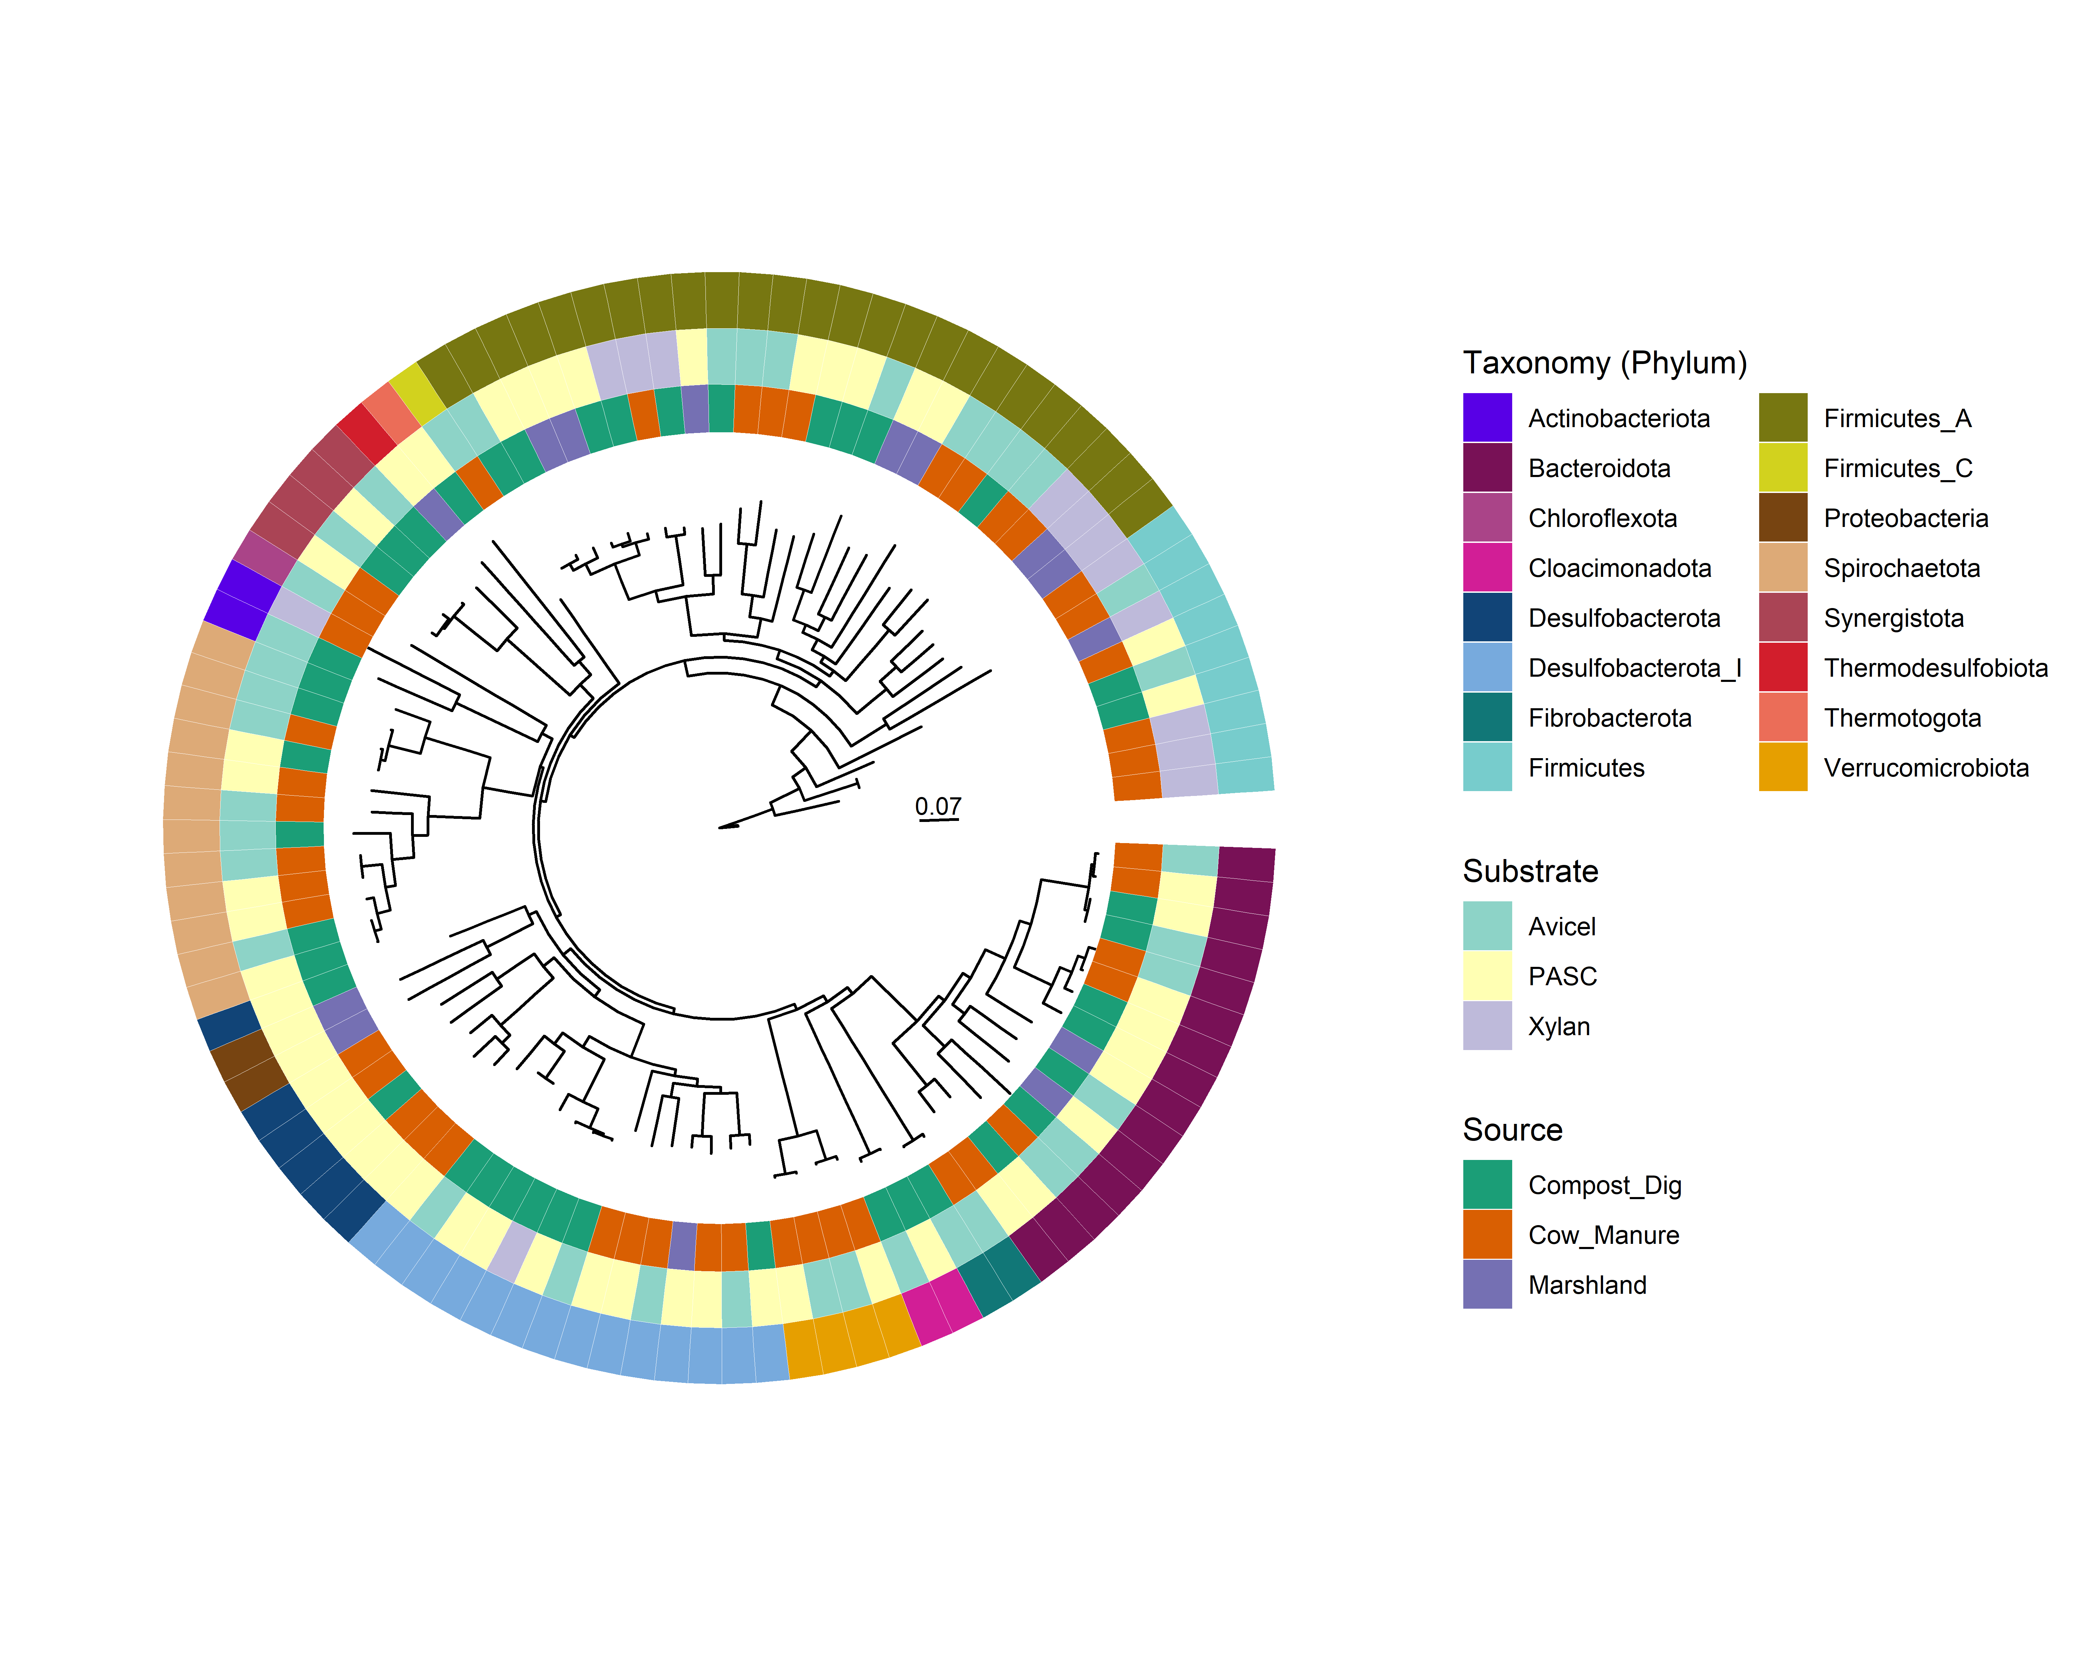 Figure 6. Phylogenomic tree of the metagenome assembled genomes (MAGs) recovered from the enrichment cultures. Tree was constructed using PhyloPhlAn database that comprises 400 universal marker genes (Asnicar et al. 2020).

The functional potential of the enriched communities showed many MAGs that harbour genes related to cellulose and hemicellulose degradation. However, for some MAGs we were not able to find any (Suppl. Figure XXX). This pattern was also the same when we focused on the MAGs that had a coverage bigger than 5% of the reads (Figure 7).

In the heatmap clusterization, we can observe four different groups. In the first three, we observe MAGs that have many genes related with cellulose and hemicellulose degradation. In the first one, we have representatives of *Bacteroides* genus and Lachnospiraceae family, and in the second from Fibro-01 (Figure 7). Interestingly, some MAGs from these two groups came from different inoculum sources, but were enriched in the same substrate. That is the case for *Bacteroides graminisolvens* strains CH7-bin.13 (cow manure), CH13-bin.4 and CH15-bin.1 (compost and digestate); *Lacrimispora* sp. strains CH1-bin.6 (Marshland soil) and CH15-bin.16 (compost and digestate); and Fibrio-01 strains CH13-bin.12 (compost and digestate) and CH8-bin.22 (cow manure). For Fibrio-01 and *Bacteroides* strains, values of average nucleotide identity were bigger than 97% (Figure 8).

Regarding group 3, where many MAGs also harboured cellulose and hemicellulose degradation genes, Clostridia class had most representants, but the MAG *Bifidobacterium* sp. CH9-bin.0, belonging to the class Actinomycetia, presented a higher coverage (65%) in the enrichment culture from cow manure enriched with Xylan (Figure 7).

The fourth group presented many MAGs representatives that didn’t have any genes related to cellulose and hemicellulose degradation, and they all belonged to Desulfovibrionia class. One particular MAG from this class, *Halodesulfovibrio* sp. CH7-bin.23, presented a higher coverage of sequencing reads (44.86%). But also in group four, we found *Sphaerochaeta* sp. and *Clostridium* sp. with interesting to cellulose and hemicellulose degradation potential. Also, *Clostridium* sp. presented also many genes related to organic compounds production (Figure 7).

Regarding the production of organic compounds, namely volatile fatty acids, ethanol and lactic acid, we could observe that many of the genes related with such process can be found in the MAGs, indicating their potential to producing such compounds (Figure 7).

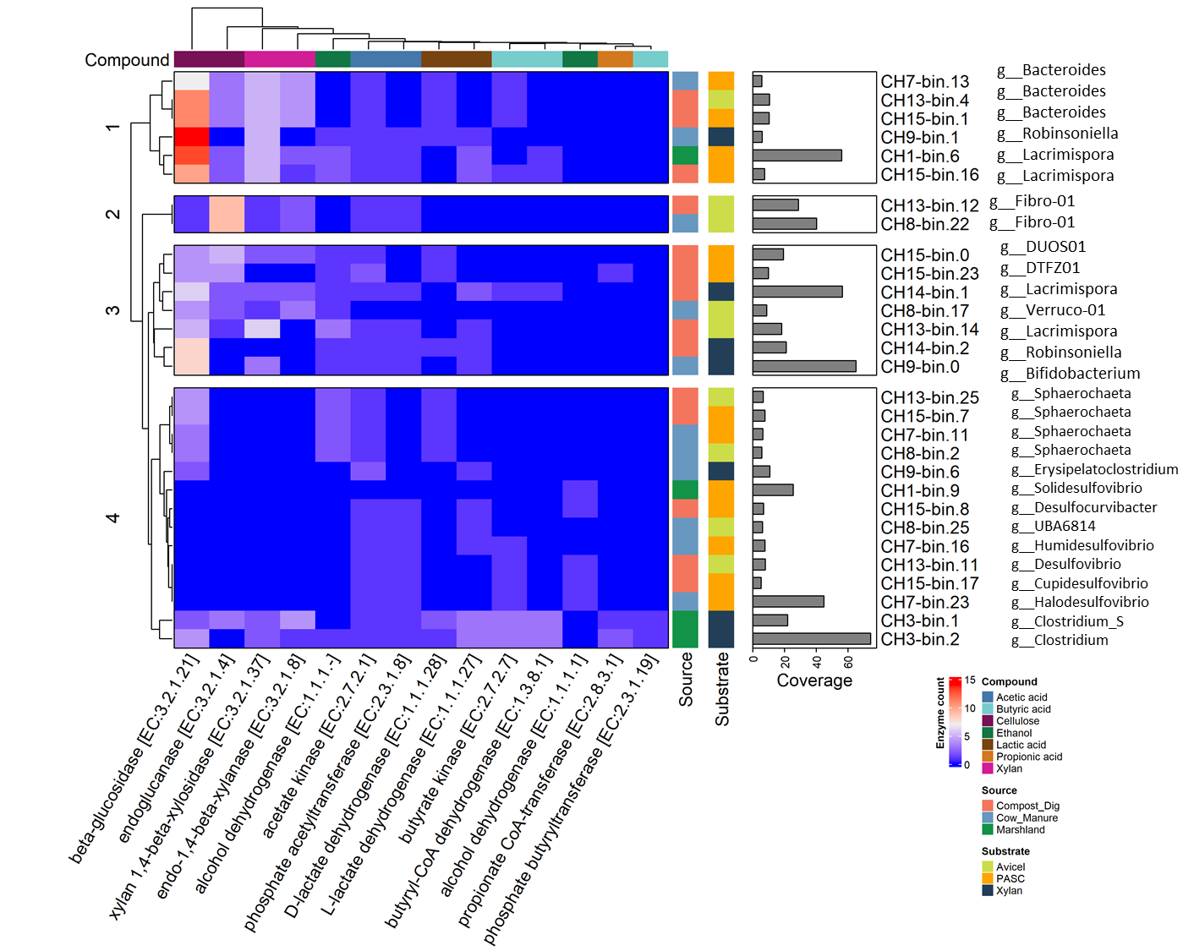

Figure 7. Heatmap constructed with the more abundant metagenome assembled genomes (MAGs) recovered from the enrichment cultures. Key genes are shown from different compounds degradation (Cellulose and Xylan), or production (Acetic acid, Butyric acid, Ethanol, Lactic acid and Propionic acid). Coverage of the MAGs are based on reads alignment, values are expressed in percentage.

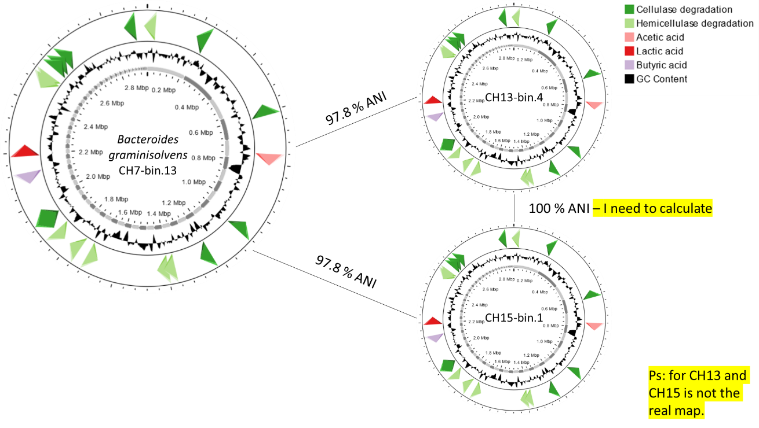

Figure 8. Comparison of the metagenome assembled genomes (MAGs) from the same bacterial genera (Bacteroides) that were isolated from different inoculum sources (strain CH7-bin.13 from cow manure, and strains CH13-bin.4 and CH15-bin.1 from compost and digestate). Values of Average Nucleotide Identity (ANI) are shown.

**3.3 Degradation of cellulose and hemicellulose for selected enrichment cultures**

Figure 8. Degradation of xylan or Avicel® in the enrichment cultures. Each bar represents the degradation of hemicellulose after two weeks and of cellulose after 5 weeks of cultivation.

The xylan/cellulose content in the positive controls ranged between 70 and 160 mg/l. These low values have been expected since with the inoculum small amounts of xylan/cellulose have been added from the precultures. The xylan/ cellulose content of the sterile controls was mostly about 8.5 g/L. Only the sterile control for the xylan enrichment cultures from marshland soil showed about 6 g/L. Assuming the content of the sterile controls as the initial concentration in the enrichment cultures the degradation of xylan/cellulose have been calculated in percentage (Figure 9). The xylan enrichment culture from compost and digestate and from marshland soil degraded almost 100% of the xylan after two weeks of cultivation. While the xylan enrichment culture from cow manure degraded about 70% of the initial content. The enrichment cultures with Avicel® on the other side have been cultivated three weeks longer, but from compost and digestate only 10% and from cow manure 20 % have been degraded.

**4. Discussion**

The use of microbial communities capable of effectively converting lignocellulose biomass into green chemicals is vital for an environmentally friendly circular economy. Green chemicals, such as VFAs or MCCAs, can have several agro-industrial applications (Chang et al. 2010; Cavalcante et al. 2017). In our work, we successfully enriched microbial communities from inoculum sources known for their lignocellulose degradation potential, e.g., cow manure, to convert this complex substrate into green chemicals. We further characterized the taxonomy and function potential of the enriched communities, gaining valuable insights about the microbial processes for lignocellulose conversion into green chemicals.

**Bacterial composition and chemical compounds production are influenced by inoculum origin source and substrate**

As expected, the enrichment process decreased the initial diversity found in the different inoculum sources. The minimal media, in combination with cellulose or xylan used as substrates, imposed a selective pressure towards the growth of microbes that can degrade the substrates (trophic-like level 1), and those that can benefit from the products generated from the later (trophic-like level 2 or further). This can be noticed in other works that performed enrichment processes with lignocellulosic substrate and different inoculum sources, such as herbivore gut (Peng et al. 2021), and digesters (Jia et al. 2018). In our work, marshland soil as inoculum source performed worse in cellulase substrate, when compared to cow manure and compost and digestate. Marshland soil is an interesting source of microorganisms capable of degrading lignocellulose compounds (Cortes-Tolalpa et al. 2018; Leadbeater et al. 2021), although they are not so well explored. The fact that the enrichment culture with marshland soil presented lower levels of bacterial diversity suggests that the conditions of the enrichment culture process did not favour the microbes presented there. This highlight the necessity of more studies in marsh to explore the potential of lignocellulose degradation in such environment.

In our work, the combination of distinct inoculum sources enriched in different substrates, reflected on the taxonomy and functional potential of the communities. Here, the results of all the analysis are presented together to improve comprehension.

**Cellulose enrichment cultures**

The cellulose enrichment cultures from cow manure and compost and digestate produced mainly acetic acid, and Avicel® presented higher product concentrations (acetic acid and carbon dioxide) then PASC. Cellulose within biomass exists in mostly crystalline form and only a small percentage in amorphous form (unorganized cellulose chains). The enzymatic hydrolysis of the latter is easier (Wada et al. 2010; Chundawat and Agarwal 2019; Delmer and Amor 1995; Ha et al. 1998; Béguin and Aubert 1994; Baeza and Freer 2000). But Weimer et al. concluded in their studies from 1991; 1990 that the crystallinity of cellulose has a relatively minor effect for its degradation rate by microbial communities from rumen due to the synergistic interactions among the cellulolytic species. They assumed that the ruminal bacteria could not adapt fast enough to the usage of celluloses with modified unit cell structures. Taking this into account our results are not surprising, especially with cow manure as inoculum.

In both cow manure and compost and digestate enrichment cultures with Avicel®, *Fibrobacter* have dominated and this genus was correlated to the propionic acid production. *Fibrobacter* is known for its ability to break down cellulosic plant biomass within the digestive systems of herbivores (Hungate 1966; Kobayashi et al. 2008; Hobson and Stewart 1997), but it can be also found in other cellulose-degrading anoxic conditions, such as termite gut, landfill sites and freshwater lakes (Ransom-Jones et al. 2012). Interestingly, we recovered MAGs from Fibrio-01 from the two enrichments, and they are highly similar to each other (98.9% ANI), suggesting that the selective pressure of microcrystalline cellulose privileged this genus. The Fibrio-01 MAGs harbour several copies of endoglucanase gene [EC:3.2.1.4], which might be related with cellulose degradation. In fact, *Fibrobacter succinogenes* one of the two cultivated species within its phylumis known to be able to degrade crystalline cellulose (Suen et al. 2011). Interestingly, it produces hemicellulose degrading enzymes in order to remove it and to get access to the cellulose. According to its genes, it lacks the capacity to transport and metabolize hydrolytic products derived from non-cellulose polysaccharide, which makes cellulose its sole energy source (Suen et al. 2011). And even though the correlation analysis pointed to the production of propionic acid by *Fibrobacter*, we did not find the gene related to propionic production (propionate CoA-transferase [EC:2.8.3.1] in the MAGs.

*Bacteroides* was also an abundant genus in cellulose enrichment culture. In fact, we recovered several MAGs belonging to the *Bacteroides graminisolvens* species. The type strain of this species was described as being able to utilize cellobiose as carbon source, but not carboxymethylcellulose and cellulose (Nishiyama et al. 2009). MAGs from this species recovered in the enrichment culture harbour many copies of endoglucanase [EC:3.2.1.4], which attacks randomly at the internal sites of cellulose, and beta-glucosidase [EC:3.2.1.21], which hydrolyzes cellooligosaccharides and cellobiose, giving the MAGs the potential to degrade cellulose (Sharma et al. 2016). Also, the fact that they were present in high abundance in two different inoculum sources enriched in cellulose, highlights the importance of this species for the enrichment cultures. In fact, Bacteroidota is a dominant group colonizing the rumen (Gharechahi et al. 2023), and it was reported in many studies that accessed the potential of lignocellulose degradation (Kukkar et al. 2022).

In our work, in the heatmap analysis done with the MAGs, *Bacteroides* clustered together with representants of *Lacrimispora*, from Lachnospiraceae family, and they both harboured many genes related with their lignocellulose degradation capability. Interestingly, the highest lignocellulose degradation rate of a wheat straw termite‑enriched microbiome happened when *Bacteroides* and Lachnospiraceae accounted for more than 70% of the total 16S rRNA content (Lazuka et al. 2018). It is not uncommon that members of *Bacteroides* and Clostridia are found working together biodegrading lignocellulosic biomass (Kougias et al. 2018; Wang et al. 2021), or even used as bioaugmentation (Tukanghan et al. 2021).

*Lacrimispora* is a new bacterial genus proposed due to the reclassification of *Clostridium* spp. clades (Haas and Blanchard 2020). In our work, the MAGs also harbour many genes related to the generation of organic compounds, namely acetic acid and ethanol. Representants of this family are known to produce such compounds (Zaplana et al. 2023) and we noticed a positive correlation between *Lachnoclostridium* with them (from Lachnospiraceae family, divergences on genus classification might be due to different technologies used in this work). These enrichment cultures could provide VFAs for the production of MCCAs, since acetic as well as propionic acid are valuable electron acceptors and ethanol an electron donor , which are necessary for the production of medium-chain carboxylic acids by microbial chain elongation (Wu et al. 2018; Kenealy and Waselefsky 1985).

Another genus found in the the cellulose enrichment cultures from cow manure have been *Desulfovibrio*. This genus can utilize sulfur compounds such as sulphate, which can be found in the media, as electron acceptors (Zhao et al. 2023). *Desulfovibrio*, acting as an incomplete oxidizer, is limited to oxidize organic matter to acetic acid rather than CO2. This results in an increase in the acidity of the culture medium, leading to the inhibition of bacterial growth (Roy 2004). Sulfate reduction can be an advantage, in case of high concentrations of heavy metals. The resulting sulphide reacts with them and form precipitated metal sulphide, which lead to bioremediation (Ayangbenro et al. 2018). 1982 Loka Bharati et al. studied mixed cultures containing anaerobic cellulolytic bacteria, sulfate reducers (*Desulfovibrio vulgaris*) and phototrophic bacteria (*Chromatium vinosum*). Cellulose fermentation led to the production of formic acid, lactic acid, ethanol, hydrogen and carbon dioxide. Through dissimilatory sulfate reduction, *Desulfovibrio* oxidized organic acids, alcohol, and hydrogen, leading to the accumulation of sulfide and acetate in the medium. Since the cellulose degradation is inhibited at low pH and the precursors for chain elongation are consumed by this genus, the decrease of the sulfate concentration in the medium could be one modification to inhibit this group of bacteria.

The combination of marshland soil with cellulose substrates led to the lowest product concentrations and protein values. Also, for some samples, DNA extraction failed, not allowing taxonomic and functional analysis. Nevertheless the enrichment from marshland soil is a possibility to extend our knowledge about wetlands, since only a few studies have characterized fermentation in wetlands so far (Hunger et al. 2015). The most abundant recovered MAGs were *Lacrimispora* and *Solidesulfovibrio*, but we also recover one from *Microbacter* genus, as seen through amplicon sequencing analysis. It is not unexpected that we found such taxa present in marsh (Frates et al. 2023; Rosato et al. 2022), but in our case, they did not performed well in degrading cellulose. Alexandra Hamberger (2008) enriched on cellulose with marshland soil as inoculum a microbial community, which was able to generate many organic compound, such as formate, acetate, propionate and butyrate. The broader products spectra and the higher concentrations in comparison to our results could be explained by the usage of a complex media. The choice of a minimal media in our case leads to harsher cultivations conditions. Acetate was noticeable in our enrichment cultures from marshland soil. Hamberger got to the hypothesis that acetogenesis takes place in marshland soils. This assumption is supported by other studies, too (Horn et al. 2003; Wüst et al. 2009).

**Xylan enrichment cultures**

The cultures with xylan as substrate showed in total a much broader product range than the cellulose enrichment cultures. After two weeks the xylan enrichment cultures degraded 70-100%. These results are not surprising. In comparison to cellulose, the polymers in hemicellulose undergo easier hydrolysis. Hardwoods and agricultural residues mainly contain xylose in their hemicellulose portion (Sun and Cheng 2002; Persson et al. 2006; Lavarack et al. 2002; Emmel et al. 2003) and their backbone consists either of a homo-polymer or a hetero-polymer with short branches, which are linked by β-1,4-glucan and β-1,3-glucan bonds (Kuhad et al. 1997). A higher degradation of hemicellulose than cellulose in fermentation of corn silage, in both batch and in continuous experiments (Sträuber et al. 2016; Sträuber et al. 2012), substantiates this fact. Additionally, Ding and Himmel (2006) noted favourable decomposition of hemicellulose than cellulose during the fermentation of maize silage.

In our work, the diversity of xylan degrading enriched communities was lower when compared with the cellulose one. The less complex substrate might have increased the selection pressure, while it also allowed a less diverse community to successfully degrade the substrate. In fact, we had mainly representants from the Clostridia class in the most abundant MAGs recovered from the xylan degrading enriched communities, namely *Clostridium*, *Lacrimispora* and *Robinsoniella*, and they seem to be related both with xylan degradation, and organic compounds formation. *Robinsionella peoriensis* is the only known isolated strain of *Robinsoniella* so far, and it was isolated from pig manure (Cotta et al. 2009; Schröttner et al. 2021). *Robinsionella* seems to promote the production of lactic acid, acetic acid and ethanol based on the correlation analysis, and our MAGs show genes for such functions (alcohol dehydrogenase [EC:1.1.1-], acetate kinase [EC:2.7.2.1], and L-lactate dehydrogenase [EC:1.1.1:27], to name a few). Most lactobacilli do not have the capacity to hydrolyse lignocelluloses (John et al. 2007) and the degradation of xylan is not common trait of lactic acid bacteria so far (Boguta et al. 2014). Having an enrichment culture able to produce lactic acid directly from xylan can be an advantage. And *Lacrimispora amygdalina* have been also found with a coverage of about 56 % in the community of the xylan enrichment culture from compost and digestate. This strain is known to be able to use xylan as a substrate. It was reported in the literature that, when glucose was used as substrate, it can produce ethanol, acetate, hydrogen and carbon dioxide (Parshina et al. 2019).

The *Clostridium* MAGs from marshland soil showed an interesting potential for both xylan degradation and organic acid production. This particular enrichment presented only this genus in the most abundant MAGs, and the result is in consonance with the amplicon sequencing analysis. Probably due to the fact that these MAGs are very versatile, they were able to dominate and sustain the enrichment culture. And the correlation analysis showed a positive correlation with ethanol, formic acid and butyric acid, the latter being produced in the enrichment culture in higher titters. Fu et al. (2019) found in their microbial community analysis this genus to be the dominant functional species for butyrate production, which fits to our results. And the high activity of the butyric acid fermentation lead to high hydrogen concentrations in the enrichment culture from marshland soil. This is due to the fact that butyric fermentation is directly accompanied with the formation of hydrogen (Sikora et al. 2013).

One main difference found between metagenome and amplicon analysis in our work, was the lack of the MAG recovery from the *Caproiciproducens* genus in compost and digestate enrichment culture with xylan. We observed the caproic acid production in this enrichment, which suggests that this community contained a chain elongator. Probably it used ethanol as an electron donor, since the caproic acid concentration was high, when the concentration of ethanol was low and vice versa. The unsteady production could have been caused by the pH drops. Tang et al. 2022 studied the caproate production from xylose in mixed culture fermentation and identified the genus *Caproiciproducens* as the main caproate producer. The addition of ethanol increased the caproate concentration, while the addition of acetate deceased it slightly. This result fits to ours, since this genus was strongly correlated to the presence of caproic acid. One known strain from this genus is *Caproiciproducens galactitolivoransas.* It uses glucose and galactitol to produce H2, CO2, ethanol, acetic acid butyric acid and caproic acid. The growth of this strain was stimulated by the production of ethanol, acetic acid or butyric acid by other strains in co-cultivation (Kim et al. 2015). *Caproiciproducens* is from the Clostridia class, and it belongs to the Oscillospirales order. Even though we recovered many MAGs from Clostridia, the same order was not found.

**Conclusion**

We were able to enrich bacteria, who are able to degrade cellulose or hemicellulose and produce short chain fatty acids out of it or even the medium chain carboxylic acid caproic acid. Enrichment cultures with the most efficient substrate degradation, and with the higher production of valuable chemicals, were generated when xylan was used as substrate, or from compost and digestate as well as from cow manure when Avicel® was the substrate. These enrichment cultures could be used in consortia with lactic acid bacteria and chain elongator strains, in order to produce more valuable and sustainable medium-chain carboxylic acids from lignocellulosic waste such as straw. The xylan enrichment cultures from compost and digestate as well as from cow manure are promising sources for novel lactic acid and chain elongator isolates, which could be later useful for biotechnological applications. Additionally, the enrichment cultures from this study have the potential to harbour so far unknown enzymes, which can efficiently degrade cellulose and hemicellulose. Overall this study extended our knowledge about the potential and understanding of cellulose and hemicellulose degrading microbial communities.

**5. Acknowledgements**

* Stephanie PASC recipe
* DBFZ Ester-GC measurements

**6. Conflict of interests**

Publication bibliography

Alexandra Hamberger (2008): Struktur und Funktion von Fermentierern und Methanogenen in einem sauren Niedermoor. Dissertation. Universität Bayreuth, Bayreuth. biology, chemistry and geosciences.

Allgaier, Martin; Reddy, Amitha; Park, Joshua I.; Ivanova, Natalia; D'haeseleer, Patrik; Lowry, Steve et al. (2010): Targeted discovery of glycoside hydrolases from a switchgrass-adapted compost community. In *PloS one* 5 (1), e8812. DOI: 10.1371/journal.pone.0008812.

Amore, Antonella; Pepe, Olimpia; Ventorino, Valeria; Aliberti, Alberto; Faraco, Vincenza (2013): Cellulolytic Bacillus strains from natural habitats - A review. In *Chimica Oggi/Chemistry Today* 31, pp. 49–52.

Anveshitha, A.; Bandeppa, S.; Triveni, S.; Shailaja, K.; Latha, P. C.; Rajani, G. (2023): Isolation and Screening of Lignocellulolytic Microbes from Cow Dung for Rapid Composting of Rice Straw. In *IJECC* 13 (9), pp. 2299–2305. DOI: 10.9734/ijecc/2023/v13i92516.

Aroney, Samuel T. N.; Newell, Rhys J. P.; Nissen, J.; Camargo, Antonio P.; Tyson, Gene W.; Woodcroft, Ben J. (2024): CoverM: Read coverage calculator for metagenomics: Zenodo.

Asnicar, Francesco; Thomas, Andrew Maltez; Beghini, Francesco; Mengoni, Claudia; Manara, Serena; Manghi, Paolo et al. (2020): Precise phylogenetic analysis of microbial isolates and genomes from metagenomes using PhyloPhlAn 3.0. In *Nature communications* 11 (1), p. 2500. DOI: 10.1038/s41467-020-16366-7.

Ayangbenro, Ayansina S.; Olanrewaju, Oluwaseyi S.; Babalola, Olubukola O. (2018): Sulfate-Reducing Bacteria as an Effective Tool for Sustainable Acid Mine Bioremediation. In *Frontiers in microbiology* 9, p. 1986. DOI: 10.3389/fmicb.2018.01986.

Baeza, Joshua; Freer, Juanita (2000): Chemical characterization of wood and its components. In *Wood and Cellulosic Chemistry*, pp. 275–384.

Béguin, P.; Aubert, J. P. (1994): The biological degradation of cellulose. In *FEMS microbiology reviews* 13 (1), pp. 25–58. DOI: 10.1111/j.1574-6976.1994.tb00033.x.

Boguta, Anna Monika; Bringel, Françoise; Martinussen, Jan; Jensen, Peter Ruhdal (2014): Screening of lactic acid bacteria for their potential as microbial cell factories for bioconversion of lignocellulosic feedstocks. In *Microbial cell factories* 13 (1), p. 97. DOI: 10.1186/s12934-014-0097-0.

Callahan, Benjamin J.; McMurdie, Paul J.; Rosen, Michael J.; Han, Andrew W.; Johnson, Amy Jo A.; Holmes, Susan P. (2016): DADA2: High-resolution sample inference from Illumina amplicon data. In *Nature methods* 13 (7), pp. 581–583. DOI: 10.1038/nmeth.3869.

Cavalcante, Willame de Araújo; Leitão, Renato Carrhá; Gehring, Tito A.; Angenent, Largus T.; Santaella, Sandra Tédde (2017): Anaerobic fermentation for n-caproic acid production: A review. In *Process Biochemistry* 54, pp. 106–119. DOI: 10.1016/j.procbio.2016.12.024.

Chang, Ho Nam; Kim, Nag-Jong; Kang, Jongwon; Jeong, Chang Moon (2010): Biomass-derived volatile fatty acid platform for fuels and chemicals. In *Biotechnol Bioproc E* 15 (1), pp. 1–10. DOI: 10.1007/s12257-009-3070-8.

Chaumeil, Pierre-Alain; Mussig, Aaron J.; Hugenholtz, Philip; Parks, Donovan H. (2019): GTDB-Tk: a toolkit to classify genomes with the Genome Taxonomy Database. In *Bioinformatics (Oxford, England)*. DOI: 10.1093/bioinformatics/btz848.

Cheng, Yan Fen; Edwards, Joan E.; Allison, Gordon G.; Zhu, Wei-Yun; Theodorou, Michael K. (2009): Diversity and activity of enriched ruminal cultures of anaerobic fungi and methanogens grown together on lignocellulose in consecutive batch culture. In *Bioresource technology* 100 (20), pp. 4821–4828. DOI: 10.1016/j.biortech.2009.04.031.

Chundawat, Shishir P. S.; Agarwal, Umesh P. (2019): Swelling by Hydrochloric Acid Partially Retains Cellulose-I Type Allomorphic Ultrastructure But Enhances Susceptibility toward Cellulase Hydrolysis Such as Highly Amorphous Cellulose. In Micholas Dean Smith (Ed.): Understanding Lignocellulose: Synergistic Computational and Analytic Methods, vol. 1338. Washington, DC: American Chemical Society (ACS Symposium Series), pp. 69–88.

Cortes-Tolalpa, Larisa; Norder, Justin; van Elsas, Jan Dirk; Falcao Salles, Joana (2018): Halotolerant microbial consortia able to degrade highly recalcitrant plant biomass substrate. In *Appl Microbiol Biotechnol* 102 (6), pp. 2913–2927. DOI: 10.1007/s00253-017-8714-6.

Cotta, Michael A.; Whitehead, Terence R.; Falsen, Enevold; Moore, Edward; Lawson, Paul A. (2009): Robinsoniella peoriensis gen. nov., sp. nov., isolated from a swine-manure storage pit and a human clinical source. In *International journal of systematic and evolutionary microbiology* 59 (Pt 1), pp. 150–155. DOI: 10.1099/ijs.0.65676-0.

Das, Arijit; Bhattacharya, Sourav; Murali, Lakshmi (2010): Production of Cellulase from a Thermophilic Bacillus sp. Isolated from Cow Dung. In *American-Eurasian Journal of Agricultural & Environmental Sciences* 8, pp. 685–691.

Delmer, D. P.; Amor, Y. (1995): Cellulose biosynthesis. In *The Plant cell* 7 (7), pp. 987–1000. DOI: 10.1105/tpc.7.7.987.

Denman, Stuart E.; McSweeney, Christopher S. (2006): Development of a real-time PCR assay for monitoring anaerobic fungal and cellulolytic bacterial populations within the rumen. In *FEMS microbiology ecology* 58 (3), pp. 572–582. DOI: 10.1111/j.1574-6941.2006.00190.x.

DG for Research and Innovation of the EC (2018): Bioeconomy: the European way to use our natural resources. Action plan 2018.

Ding, Shi-You; Himmel, Michael E. (2006): The maize primary cell wall microfibril: a new model derived from direct visualization. In *Journal of agricultural and food chemistry* 54 (3), pp. 597–606. DOI: 10.1021/jf051851z.

Elbeshbishy, Elsayed; Nakhla, George; Hafez, Hisham (2012): Biochemical methane potential (BMP) of food waste and primary sludge: influence of inoculum pre-incubation and inoculum source. In *Bioresource technology* 110, pp. 18–25. DOI: 10.1016/j.biortech.2012.01.025.

Emmel, Alexandre; Mathias, Alvaro L.; Wypych, Fernando; Ramos, Luiz P. (2003): Fractionation of Eucalyptus grandis chips by dilute acid-catalysed steam explosion. In *Bioresource technology* 86 (2), pp. 105–115. DOI: 10.1016/S0960-8524(02)00165-7.

Frates, Erin S.; Spietz, Rachel L.; Silverstein, Michael R.; Girguis, Peter; Hatzenpichler, Roland; Marlow, Jeffrey J. (2023): Natural and anthropogenic carbon input affect microbial activity in salt marsh sediment. In *Frontiers in microbiology* 14, p. 1235906. DOI: 10.3389/fmicb.2023.1235906.

Fu, Xindi; Jin, Xi; Pan, Chao; Ye, Rong; Wang, Qian; Wang, Hongtao; Lu, Wenjing (2019): Enhanced butyrate production by transition metal particles during the food waste fermentation. In *Bioresource technology* 291, p. 121848. DOI: 10.1016/j.biortech.2019.121848.

Gharechahi, Javad; Vahidi, Mohammad Farhad; Sharifi, Golandam; Ariaeenejad, Shohreh; Ding, Xue-Zhi; Han, Jian-Lin; Salekdeh, Ghasem Hosseini (2023): Lignocellulose degradation by rumen bacterial communities: New insights from metagenome analyses. In *Environmental research* 229, p. 115925. DOI: 10.1016/j.envres.2023.115925.

Grant, Jason R.; Enns, Eric; Marinier, Eric; Mandal, Arnab; Herman, Emily K.; Chen, Chih-Yu et al. (2023): Proksee: in-depth characterization and visualization of bacterial genomes. In *Nucleic acids research* 51 (W1), W484-W492. DOI: 10.1093/nar/gkad326.

Guobao Song; Jie Song; Shushen Zhang: Modelling the policies of optimal straw use for maximum mitigation of climate change in China from a system perspective.

Ha, M. A.; Apperley, D. C.; Evans, B. W.; Huxham, I. M.; Jardine, W. G.; Viëtor, R. J. et al. (1998): Fine structure in cellulose microfibrils: NMR evidence from onion and quince. In *The Plant journal : for cell and molecular biology* 16 (2), pp. 183–190. DOI: 10.1046/j.1365-313x.1998.00291.x.

Haas, Kelly N.; Blanchard, Jeffrey L. (2020): Reclassification of the Clostridium clostridioforme and Clostridium sphenoides clades as Enterocloster gen. nov. and Lacrimispora gen. nov., including reclassification of 15 taxa. In *International journal of systematic and evolutionary microbiology* 70 (1), pp. 23–34. DOI: 10.1099/ijsem.0.003698.

Hassen, A.; Belguith, K.; Jedidi, N.; Cherif, A.; Cherif, M.; Boudabous, A. (2001): Microbial characterization during composting of municipal solid waste. In *Bioresource technology* 80 (3), pp. 217–225. DOI: 10.1016/S0960-8524(01)00065-7.

Hemme, Christopher L.; Fields, Matthew W.; He, Qiang; Deng, Ye; Lin, Lu; Tu, Qichao et al. (2011): Correlation of genomic and physiological traits of thermoanaerobacter species with biofuel yields. In *Applied and environmental microbiology* 77 (22), pp. 7998–8008. DOI: 10.1128/AEM.05677-11.

Henderson, Gemma; Cox, Faith; Ganesh, Siva; Jonker, Arjan; Young, Wayne; Janssen, Peter H. (2015): Rumen microbial community composition varies with diet and host, but a core microbiome is found across a wide geographical range. In *Scientific reports* 5, p. 14567. DOI: 10.1038/srep14567.

Hobson, P. N.; Stewart, C. S. (1997): The Rumen Microbial Ecosystem. Dordrecht: Springer Netherlands.

Horn, Marcus A.; Matthies, Carola; Küsel, Kirsten; Schramm, Andreas; Drake, Harold L. (2003): Hydrogenotrophic methanogenesis by moderately acid-tolerant methanogens of a methane-emitting acidic peat. In *Applied and environmental microbiology* 69 (1), pp. 74–83. DOI: 10.1128/AEM.69.1.74-83.2003.

Hungate, Robert E. (1966): Rumen and Its Microbes. s.l.: Elsevier Science. Available online at http://gbv.eblib.com/patron/FullRecord.aspx?p=3008790.

Hunger, Sindy; Gößner, Anita S.; Drake, Harold L. (2015): Anaerobic trophic interactions of contrasting methane-emitting mire soils: processes versus taxa. In *FEMS microbiology ecology* 91 (5). DOI: 10.1093/femsec/fiv045.

Jain, Chirag; Rodriguez-R, Luis M.; Phillippy, Adam M.; Konstantinidis, Konstantinos T.; Aluru, Srinivas (2018): High throughput ANI analysis of 90K prokaryotic genomes reveals clear species boundaries. In *Nature communications* 9 (1), p. 5114. DOI: 10.1038/s41467-018-07641-9.

Jia, Yangyang; Ng, Siu-Kin; Lu, Hongyuan; Cai, Mingwei; Lee, Patrick K. H. (2018): Genome-centric metatranscriptomes and ecological roles of the active microbial populations during cellulosic biomass anaerobic digestion. In *Biotechnology for biofuels* 11, p. 117. DOI: 10.1186/s13068-018-1121-0.

John, Rojan P.; Nampoothiri, K. Madhavan; Pandey, Ashok (2007): Fermentative production of lactic acid from biomass: an overview on process developments and future perspectives. In *Applied microbiology and biotechnology* 74 (3), pp. 524–534. DOI: 10.1007/s00253-006-0779-6.

Kato, Souichiro; Haruta, Shin; Cui, Zong Jun; Ishii, Masaharu; Igarashi, Yasuo (2008): Network relationships of bacteria in a stable mixed culture. In *Microbial ecology* 56 (3), pp. 403–411. DOI: 10.1007/s00248-007-9357-4.

Kenealy, William R.; Waselefsky, David M. (1985): Studies on the substrate range of Clostridium kluyveri; the use of propanol and succinate. In *Arch. Microbiol.* 141 (3), pp. 187–194. DOI: 10.1007/BF00408056.

Kim, Byung-Chun; Seung Jeon, Byoung; Kim, Seil; Kim, Hyunook; Um, Youngsoon; Sang, Byoung-In (2015): Caproiciproducens galactitolivorans gen. nov., sp. nov., a bacterium capable of producing caproic acid from galactitol, isolated from a wastewater treatment plant. In *International journal of systematic and evolutionary microbiology* 65 (12), pp. 4902–4908. DOI: 10.1099/ijsem.0.000665.

Klindworth, Anna; Pruesse, Elmar; Schweer, Timmy; Peplies, Jörg; Quast, Christian; Horn, Matthias; Glöckner, Frank Oliver (2013): Evaluation of general 16S ribosomal RNA gene PCR primers for classical and next-generation sequencing-based diversity studies. In *Nucleic acids research* 41 (1), e1. DOI: 10.1093/nar/gks808.

Kobayashi, Y.; Shinkai, T.; Koike, S. (2008): Ecological and physiological characterization shows that Fibrobacter succinogenes is important in rumen fiber digestion - review. In *Folia microbiologica* 53 (3), pp. 195–200. DOI: 10.1007/s12223-008-0024-z.

Kougias, Panagiotis G.; Campanaro, Stefano; Treu, Laura; Tsapekos, Panagiotis; Armani, Andrea; Angelidaki, Irini (2018): Spatial Distribution and Diverse Metabolic Functions of Lignocellulose-Degrading Uncultured Bacteria as Revealed by Genome-Centric Metagenomics. In *Applied and environmental microbiology* 84 (18). DOI: 10.1128/AEM.01244-18.

Kuhad, R. C.; Singh, A.; Eriksson, K. E. (1997): Microorganisms and enzymes involved in the degradation of plant fiber cell walls. In *Advances in biochemical engineering/biotechnology* 57, pp. 45–125. DOI: 10.1007/BFb0102072.

Kukkar, Deepak; Sharma, Pushpender Kumar; Kim, Ki-Hyun (2022): Recent advances in metagenomic analysis of different ecological niches for enhanced biodegradation of recalcitrant lignocellulosic biomass. In *Environmental research* 215 (Pt 2), p. 114369. DOI: 10.1016/j.envres.2022.114369.

Langmead, Ben; Salzberg, Steven L. (2012): Fast gapped-read alignment with Bowtie 2. In *Nature methods* 9 (4), pp. 357–359. DOI: 10.1038/nmeth.1923.

Lavarack, B. P.; Griffin, G. J.; Rodman, D. (2002): The acid hydrolysis of sugarcane bagasse hemicellulose to produce xylose, arabinose, glucose and other products. In *Biomass and Bioenergy* 23 (5), pp. 367–380. DOI: 10.1016/S0961-9534(02)00066-1.

Lazuka, Adèle; Auer, Lucas; O'Donohue, Michael; Hernandez-Raquet, Guillermina (2018): Anaerobic lignocellulolytic microbial consortium derived from termite gut: enrichment, lignocellulose degradation and community dynamics. In *Biotechnology for biofuels* 11, p. 284. DOI: 10.1186/s13068-018-1282-x.

Leadbeater, Daniel R.; Oates, Nicola C.; Bennett, Joseph P.; Li, Yi; Dowle, Adam A.; Taylor, Joe D. et al. (2021): Mechanistic strategies of microbial communities regulating lignocellulose deconstruction in a UK salt marsh. In *Microbiome* 9 (1), p. 48. DOI: 10.1186/s40168-020-00964-0.

Li, L.; Yang, X.; Li, X.; Zheng, M.; Chen, J.; Zhang, Z. (2010): The Influence of Inoculum Sources on Anaerobic Biogasification of NaOH-treated Corn Stover. In *Energy Sources, Part A: Recovery, Utilization, and Environmental Effects* 33 (2), pp. 138–144. DOI: 10.1080/15567030902937192.

Loka Bharati, P. A.; Baulaigue, Renee; Matheron, Robert (1982): Degradation of cellulose by mixed cultures of fermentative bacteria and anaerobic sulfur bacteria. In *Zentralblatt für Bakteriologie Mikrobiologie und Hygiene: I. Abt. Originale C: Allgemeine, angewandte und ökologische Mikrobiologie* 3 (4), pp. 466–474. DOI: 10.1016/S0721-9571(82)80003-3.

Lu, Yi-Tong; Chen, Xiao-Bin; Zhou, Pei; Li, Zhen-Hong (2005): Screening on oil-decomposing microorganisms and application in organic waste treatment machine. In *Journal of environmental sciences (China)* 17 (3), pp. 440–444.

Martinez, Diego; Larrondo, Luis F.; Putnam, Nik; Gelpke, Maarten D. Sollewijn; Huang, Katherine; Chapman, Jarrod et al. (2004): Genome sequence of the lignocellulose degrading fungus Phanerochaete chrysosporium strain RP78. In *Nature biotechnology* 22 (6), pp. 695–700. DOI: 10.1038/nbt967.

Mayende, Lungisa; Wilhelmi, Brendan; Pletschke, Brett (2006): Cellulases (CMCases) and polyphenol oxidases from thermophilic. In *Soil Biology and Biochemistry* 38, pp. 2963–2966. DOI: 10.1016/j.soilbio.2006.03.019.

McMurdie, Paul J.; Holmes, Susan (2013): phyloseq: an R package for reproducible interactive analysis and graphics of microbiome census data. In *PloS one* 8 (4), e61217. DOI: 10.1371/journal.pone.0061217.

Nishiyama, Tomomi; Ueki, Atsuko; Kaku, Nobuo; Watanabe, Kazuya; Ueki, Katsuji (2009): Bacteroides graminisolvens sp. nov., a xylanolytic anaerobe isolated from a methanogenic reactor treating cattle waste. In *International journal of systematic and evolutionary microbiology* 59 (Pt 8), pp. 1901–1907. DOI: 10.1099/ijs.0.008268-0.

Nurk, Sergey; Meleshko, Dmitry; Korobeynikov, Anton; Pevzner, Pavel A. (2017): metaSPAdes: a new versatile metagenomic assembler. In *Genome research* 27 (5), pp. 824–834. DOI: 10.1101/gr.213959.116.

Ortiz, Rodomiro; Sayre, Kenneth D.; Govaerts, Bram; Gupta, Raj; Subbarao, G. V.; Ban, Tomohiro et al. (2008): Climate change: Can wheat beat the heat? In *Agriculture, Ecosystems & Environment* 126 (1-2), pp. 46–58. DOI: 10.1016/j.agee.2008.01.019.

Parks, Donovan H.; Imelfort, Michael; Skennerton, Connor T.; Hugenholtz, Philip; Tyson, Gene W. (2015): CheckM: assessing the quality of microbial genomes recovered from isolates, single cells, and metagenomes. In *Genome research* 25 (7), pp. 1043–1055. DOI: 10.1101/gr.186072.114.

Parshina, Sofiya Nikolaevna; Strepis, Nikolaos; Aalvink, Steven; Nozhevnikova, Alla N.; Stams, Alfons J. M.; Sousa, Diana Z. (2019): Trichococcus shcherbakoviae sp. nov., isolated from a laboratory-scale anaerobic EGSB bioreactor operated at low temperature. In *International journal of systematic and evolutionary microbiology* 69 (2), pp. 529–534. DOI: 10.1099/ijsem.0.003193.

Paul, S. (2003): Heterogenität der Sulfatreduktion im Einzugsgebiet des Lehstenbachs, Fichtelgebirge. Diplomarbeit. Universität Bayreuth, Deutschland.

Peng, Xuefeng; Wilken, St Elmo; Lankiewicz, Thomas S.; Gilmore, Sean P.; Brown, Jennifer L.; Henske, John K. et al. (2021): Genomic and functional analyses of fungal and bacterial consortia that enable lignocellulose breakdown in goat gut microbiomes. In *Nature microbiology* 6 (4), pp. 499–511. DOI: 10.1038/s41564-020-00861-0.

Pereira, L. G.; Cavalett, O.; Bonomi, A.; Zhang, Y.; Warner, E.; Chum, H. L. (2019): Comparison of biofuel life-cycle GHG emissions assessment tools: The case studies of ethanol produced from sugarcane, corn, and wheat. In *Renewable and Sustainable Energy Reviews* 110, pp. 1–12. DOI: 10.1016/j.rser.2019.04.043.

Persson, Tobias; Matusiak, Mikael; Zacchi, Guido; Jönsson, Ann-Sofi (2006): Extraction of hemicelluloses from process water from the production of masonite. In *Desalination* 199 (1-3), pp. 411–412. DOI: 10.1016/j.desal.2006.03.093.

Phan-huy, Catherine; Göswein, Verena; Habert, Guillaume (2023a): Climate-effective use of straw in the EU bioeconomy—comparing avoided and delayed emissions in the agricultural, energy and construction sectors. In *Environ. Res. Lett.* 18 (12), p. 124004. DOI: 10.1088/1748-9326/ad0517.

Phan-huy, Catherine; Göswein, Verena; Habert, Guillaume (2023b): Climate-effective use of straw in the EU bioeconomy—comparing avoided and delayed emissions in the agricultural, energy and construction sectors. In *Environ. Res. Lett.* 18 (12), p. 124004. DOI: 10.1088/1748-9326/ad0517.

Quast, Christian; Pruesse, Elmar; Yilmaz, Pelin; Gerken, Jan; Schweer, Timmy; Yarza, Pablo et al. (2013): The SILVA ribosomal RNA gene database project: improved data processing and web-based tools. In *Nucleic acids research* 41 (Database issue), D590-6. DOI: 10.1093/nar/gks1219.

Ransom-Jones, Emma; Jones, David L.; McCarthy, Alan J.; McDonald, James E. (2012): The Fibrobacteres: an important phylum of cellulose-degrading bacteria. In *Microbial ecology* 63 (2), pp. 267–281. DOI: 10.1007/s00248-011-9998-1.

Rocha, Ulisses; Coelho Kasmanas, Jonas; Kallies, René; Saraiva, Joao Pedro; Toscan, Rodolfo Brizola; Štefanič, Polonca et al. (2024): MuDoGeR: Multi-Domain Genome recovery from metagenomes made easy. In *Molecular ecology resources* 24 (2), e13904. DOI: 10.1111/1755-0998.13904.

Rosato, Antonella; Barone, Monica; Negroni, Andrea; Brigidi, Patrizia; Fava, Fabio; Biagi, Elena et al. (2022): Bacterial colonization dynamics of different microplastic types in an anoxic salt marsh sediment and impact of adsorbed polychlorinated biphenyls on the plastisphere. In *Environmental pollution (Barking, Essex : 1987)* 315, p. 120411. DOI: 10.1016/j.envpol.2022.120411.

Roy, Michael (2004): The effects of electron donors on the growth of sulfate-reducing bacteria in copper-zinc and gold mine tailings from Timmins, Ontario. Université d'Ottawa / University of Ottawa.

S. H. Zinder; T. Anguish; S. C. Cardwell: Selective Inhibition by 2-Bromoethanesulfonate of Methanogenesis from Acetate in a Thermophilic Anaerobic Digestor.

Saha, Badal C.; Cotta, Michael A. (2006): Ethanol production from alkaline peroxide pretreated enzymatically saccharified wheat straw. In *Biotechnology progress* 22 (2), pp. 449–453. DOI: 10.1021/bp050310r.

Scarlat, Nicolae; Dallemand, Jean; Taylor, Nigel; Banja, Manjola; Sanchez Lopez, Javier; Avraamides, Marios (2019): Brief on biomass for energy in the European Union.

Schink, B. (1997): Energetics of syntrophic cooperation in methanogenic degradation. In *Microbiology and molecular biology reviews : MMBR* 61 (2), pp. 262–280. DOI: 10.1128/mmbr.61.2.262-280.1997.

Schröttner, Percy; Riedel, Thomas; Müller, Stephanie; Bunk, Boyke (2021): Robinsoniella peoriensis: Was ist bisher bekannt?

Shaffer, Michael; Borton, Mikayla A.; McGivern, Bridget B.; Zayed, Ahmed A.; La Rosa, Sabina Leanti; Solden, Lindsey M. et al. (2020): DRAM for distilling microbial metabolism to automate the curation of microbiome function. In *Nucleic acids research* 48 (16), pp. 8883–8900. DOI: 10.1093/nar/gkaa621.

Sharma, Amita; Tewari, Rupinder; Rana, Susheel Singh; Soni, Raman; Soni, Sanjeev Kumar (2016): Cellulases: Classification, Methods of Determination and Industrial Applications. In *Applied biochemistry and biotechnology* 179 (8), pp. 1346–1380. DOI: 10.1007/s12010-016-2070-3.

Sikora, Anna; Baszczyk, Mieczysaw; Jurkowski, Marcin; Zielenkiewicz, Urszula (2013): Lactic Acid Bacteria in Hydrogen-Producing Consortia: On Purpose or by Coincidence? In J. Marcelino Kongo (Ed.): Lactic Acid Bacteria - R & D for Food, Health and Livestock Purposes: InTech.

Sträuber, Heike; Lucas, Rico; Kleinsteuber, Sabine (2016): Metabolic and microbial community dynamics during the anaerobic digestion of maize silage in a two-phase process. In *Applied microbiology and biotechnology* 100 (1), pp. 479–491. DOI: 10.1007/s00253-015-6996-0.

Sträuber, Heike; Schröder, Martina; Kleinsteuber, Sabine (2012): Metabolic and microbial community dynamics during the hydrolytic and acidogenic fermentation in a leach-bed process. In *Energ Sustain Soc* 2 (1). DOI: 10.1186/2192-0567-2-13.

Suen, Garret; Weimer, Paul J.; Stevenson, David M.; Aylward, Frank O.; Boyum, Julie; Deneke, Jan et al. (2011): The complete genome sequence of Fibrobacter succinogenes S85 reveals a cellulolytic and metabolic specialist. In *PloS one* 6 (4), e18814. DOI: 10.1371/journal.pone.0018814.

Sun, Ye; Cheng, Jiayang (2002): Hydrolysis of lignocellulosic materials for ethanol production: a review. In *Bioresource technology* 83 (1), pp. 1–11. DOI: 10.1016/S0960-8524(01)00212-7.

Tang, Jie; Dai, Kun; Wang, Qing-Ting; Zheng, Si-Jie; Hong, Si-Di; Jianxiong Zeng, Raymond; Zhang, Fang (2022): Caproate production from xylose via the fatty acid biosynthesis pathway by genus Caproiciproducens dominated mixed culture fermentation. In *Bioresource technology* 351, p. 126978. DOI: 10.1016/j.biortech.2022.126978.

Timo Mallmann (2008): Hochmoore als hydrologische Archiv. Anwendung natürlicher Tracer in Mooren. Albert-Ludwigs-Universität Freiburg i. Br., Freiburg. Hydrologie. Available online at http://www.hydrology.uni-freiburg.de/abschluss/Mallmann_T_2008_DA.pdf, checked on 11/22/2023.

Trckova, M.; Matlova, L.; Hudcova, H.; Faldyna, M.; Zraly, Z.; Dvorska, L. et al. (2005): Peat as a feed supplement for animals: a literature review. In *Vet. Med.* 50 (8), pp. 361–377. DOI: 10.17221/5635-VETMED.

Tukanghan, Wisarut; Hupfauf, Sebastian; Gómez-Brandón, María; Insam, Heribert; Salvenmoser, Willi; Prasertsan, Poonsuk et al. (2021): Symbiotic Bacteroides and Clostridium-rich methanogenic consortium enhanced biogas production of high-solid anaerobic digestion systems. In *Bioresource Technology Reports* 14, p. 100685. DOI: 10.1016/j.biteb.2021.100685.

Updegraff, D. M. (1969): Semimicro determination of cellulose in biological materials. In *Analytical biochemistry* 32 (3), pp. 420–424. DOI: 10.1016/S0003-2697(69)80009-6.

Uritskiy, Gherman V.; DiRuggiero, Jocelyne; Taylor, James (2018): MetaWRAP-a flexible pipeline for genome-resolved metagenomic data analysis. In *Microbiome* 6 (1), p. 158. DOI: 10.1186/s40168-018-0541-1.

Venkata Mohan, S.; Nikhil, G. N.; Chiranjeevi, P.; Nagendranatha Reddy, C.; Rohit, M. V.; Kumar, A. Naresh; Sarkar, Omprakash (2016): Waste biorefinery models towards sustainable circular bioeconomy: Critical review and future perspectives. In *Bioresource technology* 215, pp. 2–12. DOI: 10.1016/j.biortech.2016.03.130.

Wada, Masahisa; Ike, Masakazu; Tokuyasu, Ken (2010): Enzymatic hydrolysis of cellulose I is greatly accelerated via its conversion to the cellulose II hydrate form. In *Polymer Degradation and Stability* 95 (4), pp. 543–548. DOI: 10.1016/j.polymdegradstab.2009.12.014.

Wang, Min; Liu, Yang; Jiang, Xinru; Fang, Junnan; Lyu, Qingyang; Wang, Xinhui; Yan, Zhiying (2021): Multi-omics reveal the structure and function of microbial community in co-digestion of corn straw and pig manure. In *Journal of Cleaner Production* 322, p. 129150. DOI: 10.1016/j.jclepro.2021.129150.

Weimer, P. J.; French, A. D.; Calamari, T. A. (1991): Differential fermentation of cellulose allomorphs by ruminal cellulolytic bacteria. In *Applied and environmental microbiology* 57 (11), pp. 3101–3106. DOI: 10.1128/aem.57.11.3101-3106.1991.

Weimer, P. J.; Lopez-Guisa, J. M.; French, A. D. (1990): Effect of cellulose fine structure on kinetics of its digestion by mixed ruminal microorganisms in vitro. In *Applied and environmental microbiology* 56 (8), pp. 2421–2429. DOI: 10.1128/aem.56.8.2421-2429.1990.

Wu, Jinling; Yin, Yanan; Wang, Jianlong (2018): Hydrogen-based membrane biofilm reactors for nitrate removal from water and wastewater. In *International Journal of Hydrogen Energy* 43 (1), pp. 1–15. DOI: 10.1016/j.ijhydene.2017.10.178.

Wüst, Pia K.; Horn, Marcus A.; Drake, Harold L. (2009): Trophic links between fermenters and methanogens in a moderately acidic fen soil. In *Environmental microbiology* 11 (6), pp. 1395–1409. DOI: 10.1111/j.1462-2920.2009.01867.x.

Zaplana, Tom; Miele, Solange; Tolonen, Andrew C. (2023): Lachnospiraceae are emerging industrial biocatalysts and biotherapeutics. In *Frontiers in bioengineering and biotechnology* 11, p. 1324396. DOI: 10.3389/fbioe.2023.1324396.

Zened, Asma; Combes, Sylvie; Cauquil, Laurent; Mariette, Jérôme; Klopp, Christophe; Bouchez, Olivier et al. (2013): Microbial ecology of the rumen evaluated by 454 GS FLX pyrosequencing is affected by starch and oil supplementation of diets. In *FEMS microbiology ecology* 83 (2), pp. 504–514. DOI: 10.1111/1574-6941.12011.

Zhao, Baofu; Sun, Hui; Jiang, Peng; Rizwan, Muhammad; Zhou, Mengke; Zhou, Xiaolong (2023): Study on the treatment of sulfite wastewater by Desulfovibrio. In *Bioprocess and biosystems engineering* 46 (9), pp. 1265–1278. DOI: 10.1007/s00449-023-02895-0.

Zheng, Mingxia; Li, Xiujin; Li, Laiqing; Yang, Xiaojin; He, Yanfeng (2009): Enhancing anaerobic biogasification of corn stover through wet state NaOH pretreatment. In *Bioresource technology* 100 (21), pp. 5140–5145. DOI: 10.1016/j.biortech.2009.05.045.

Zhou Hong-li; Yang Xiao; Xiong Dong-mei; Zeng Lu; Tian Kai-zhong; Xiong Xing-yao et al. (2015): A Novel Reverse-Transcriptase Real-Time PCR Method for Quantification of Viable Vibrio Parahemolyticus in Raw Shrimp Based on a Rapid Construction of Standard Curve Method. In *Research & Reviews: Journal of Microbiology and*.

Zinder, Stephen H. (1993): Physiological Ecology of Methanogens. In James G. Ferry (Ed.): Methanogenesis. Boston, MA: Springer US, pp. 128–206.